

***Spring Framework***

**Training Assignments**

|  |  |
| --- | --- |
| Document Code | 25e-BM/HR/HDCV/FSOFT |
| Version | 1.1 |
| Effective Date | 20/11/2012 |

**Hanoi, 06/2019**

RECORD OF CHANGES

|  |  |  |  |  |  |
| --- | --- | --- | --- | --- | --- |
| No | Effective Date | Change Description | Reason | Reviewer | Approver |
|  | 01/Oct/2018 | Add the new labs | Create new | DieuNT1 | VinhNV |
|  | 01/Jun/2019 | Update template | Fsoft template | DieuNT1 | VinhNV |
|  |  |  |  |  |  |
|  |  |  |  |  |  |
|  |  |  |  |  |  |
|  |  |  |  |  |  |
|  |  |  |  |  |  |
|  |  |  |  |  |  |
|  |  |  |  |  |  |
|  |  |  |  |  |  |

Contents

Objectives 4

Business needs 4

Working Environments 4

Product Architecture 5

Technologies 5

Database Relationship 5

Assignment Descriptions 7

|  |  |
| --- | --- |
|  | **CODE: JSFW.L.A102 (Blogs)**  **TYPE: LONG**  **LOC: N/A**  **DURATION: 360 MINUTES** |

# **Objectives**

After finishing the following exercises, trainees will:

* Understand Spring Core (IoC, DI)
* Practice with JDBC Templates to connect database in spring
* Use JPA for object-relational mapping
* Practice with the Spring MVC framework architecture
* Know how to write a Web application with Spring MVC Framework and Spring Data JPA

# **Business needs**

Create a Web application based on HTML, CSS, JavaScript, Ajax, Servlet, JSP, Spring framework.

The blog system that we are going to develop is a single user system. The owner of the system will be able to perform the following actions:

* Login and logout
* Create, update and delete posts
* Published, unpublished and archive posts
* Approve and delete comments

All other users are guest users who can perform the following actions:

* Read posts
* Create comments

Additional Requirements for this system include:

* The homepage of the system should display a list of the most recent posts.
* If a page contains more than 10 posts, they should be displayed in pages.
* The system should display a post together with its comments.
* The system should be able to list posts with a specified tag.
* The system should show a cloud of tags indicating their use frequencies.
* The system should show a list of most recent comments.

# Working Environments

* JDK 1.8 +
* Maven 3+
* Eclipse IDE or STS,
* MySQL DB Server/MySQL,
* Apache TomCat 7 or later,
* Internet connection,

Delivery: Source code, deployment and testing, reviewing evidences packaged in a compress archive.

# Product Architecture

Web applications are by nature distributed applications, meaning that they are programs that run on more than one computer and communicate through a network or server. Specifically, web applications are accessed with a web browser and are popular because of the ease of using the browser as a user client.

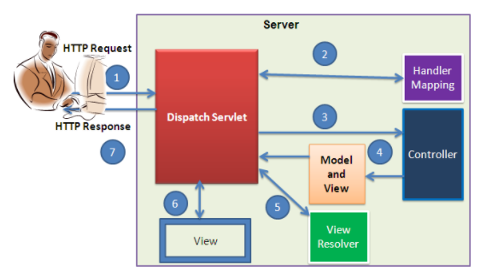

The product is implemented using MVC Pattern base on Spring Web MVC.

# Technologies

The product implements one or more technology:

* HTML & CSS
* JavaScript & Ajax
* MVC & JSP Model
* Spring Framework: IoC, Bean, SpEL, JdbcTemplate, Spring Data JPA, Interceptor, Validation, Spring Sercutity.

# Database Relationship

Based on the analysis of the requirements, we decide to use the following database tables to store the persistent data for our blog application:

* ***tbl_user*** stores the user information, including username and password.
* ***tbl_post*** stores the blog post information. It mainly consists of the following columns:
* title: required, title of the post;
* content: required, body content of the post which uses the [Markdown format](http://daringfireball.net/projects/markdown/syntax);
* status: required, status of the post, which can be one of following values:

1. meaning the post is in draft and is not visible to public;
2. meaning the post is published to public;
3. meaning the post is outdated and is not visible in the post list (still accessible individually, though).

* tags: optional, a list of comma-separated words categorizing the post.
* ***tbl_comment*** stores the post comment information. Each comment is associated with a post and mainly consists of the following columns:
* author: required, the author name;
* email: required, the author email;
* url: optional, the author website URL;
* content: required, the comment content in plain text format.
* status: required, status of the comment, which indicates whether the comment is approved (value 2) or not (value 1).
* ***tbl_tag*** stores post tag frequency information that is needed to implement the tag cloud feature. The table mainly contains the following columns:
* name: required, the unique tag name;
* frequency: required, the number of times that the tag appears in posts.
* ***tbl_lookup*** stores generic lookup information. It is essentially a map between integer values and text strings. The former is the data representation in our code, while the latter is the corresponding presentation to end users. For example, we use integer 1 to represent the draft post status and stringDraft to display this status to end users. This table mainly contains the following columns:
* name: the textual representation of the data item that is to be displayed to end users;
* code: the integer representation of the data item;
* type: the type of the data item;
* position: the relative display order of the data item among other items of the same type.

The following entity-relation (ER) diagram shows the table structure and relationships about the above tables

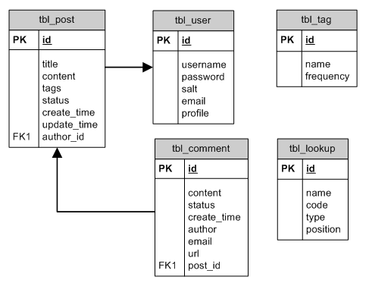

# Assignment Descriptions

1. ***Create the pages as below:***

* Home page:

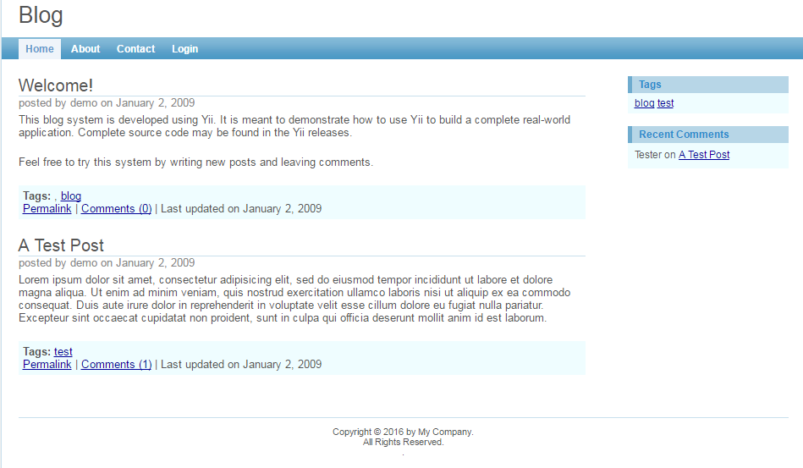

* Login page:

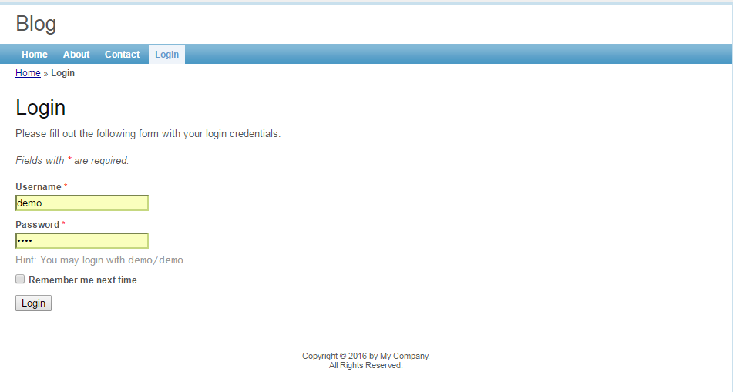

* About page

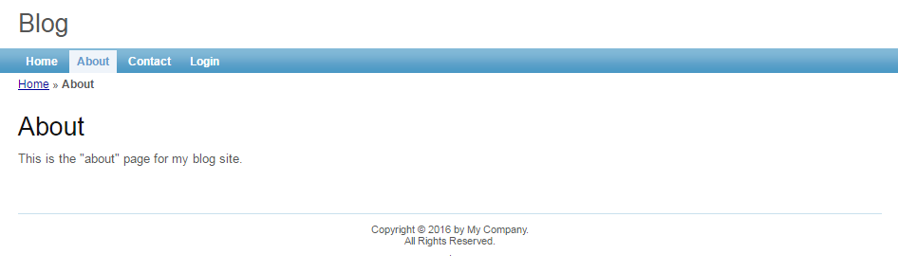

* Contact Page

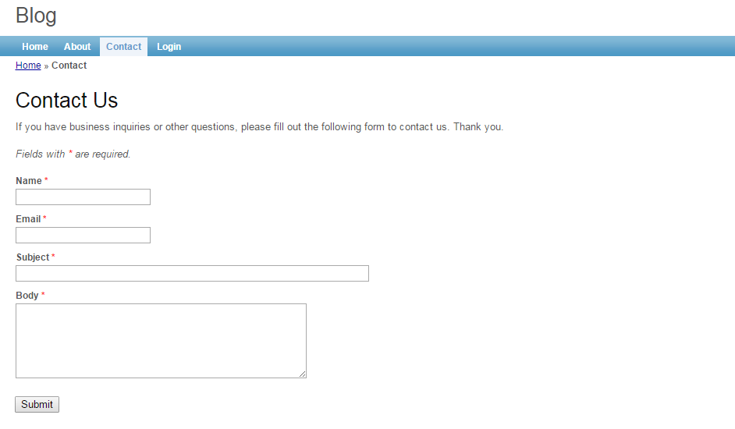

* Create post

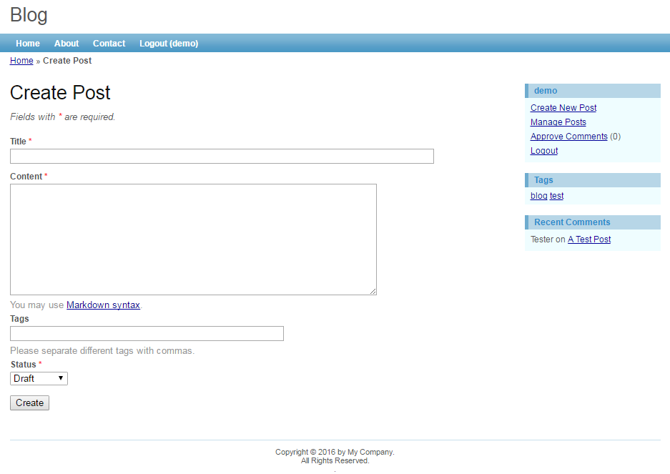

* Manage post page

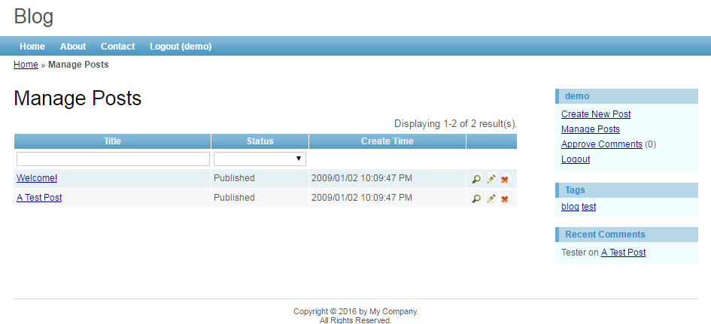

1. **Screen Requirement:**

CSS Box Model as below:

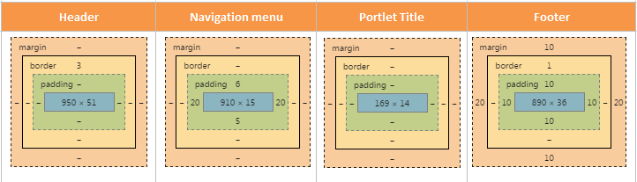

* Let design based The screen illustrated.
* Add User must be a popup.
* Placeholder text in inputs has a light gray color. You need to define the placeholder for input items on the above screen.
* Add a new file fStyle.css to customize your screen, it will basd on convention of CSS style.
* The **Index** page must contain 3 parts: Banner, Menu, Body

1. **Functional Requirement:**

As you may have found that the skeleton application already provides user authentication by checking if the username and password are both ***demo*** or ***admin***. In this section, we will modify the corresponding code so that the authentication is done against the User database table.

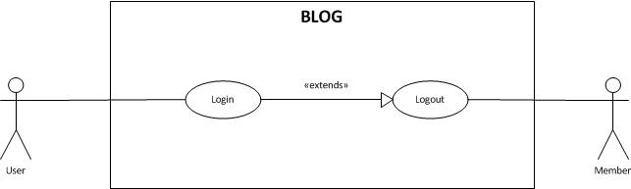

In our blog application, a post may be displayed among a list of posts or by itself. Managing posts mainly refers to listing posts in an administrative view that allows us to see posts with all statuses, updating them and deleting them. In this assignment, you must finish the feature in use case as below:

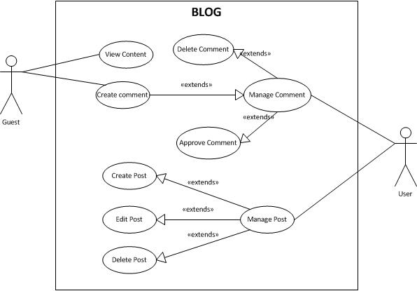

**-- THE END --**